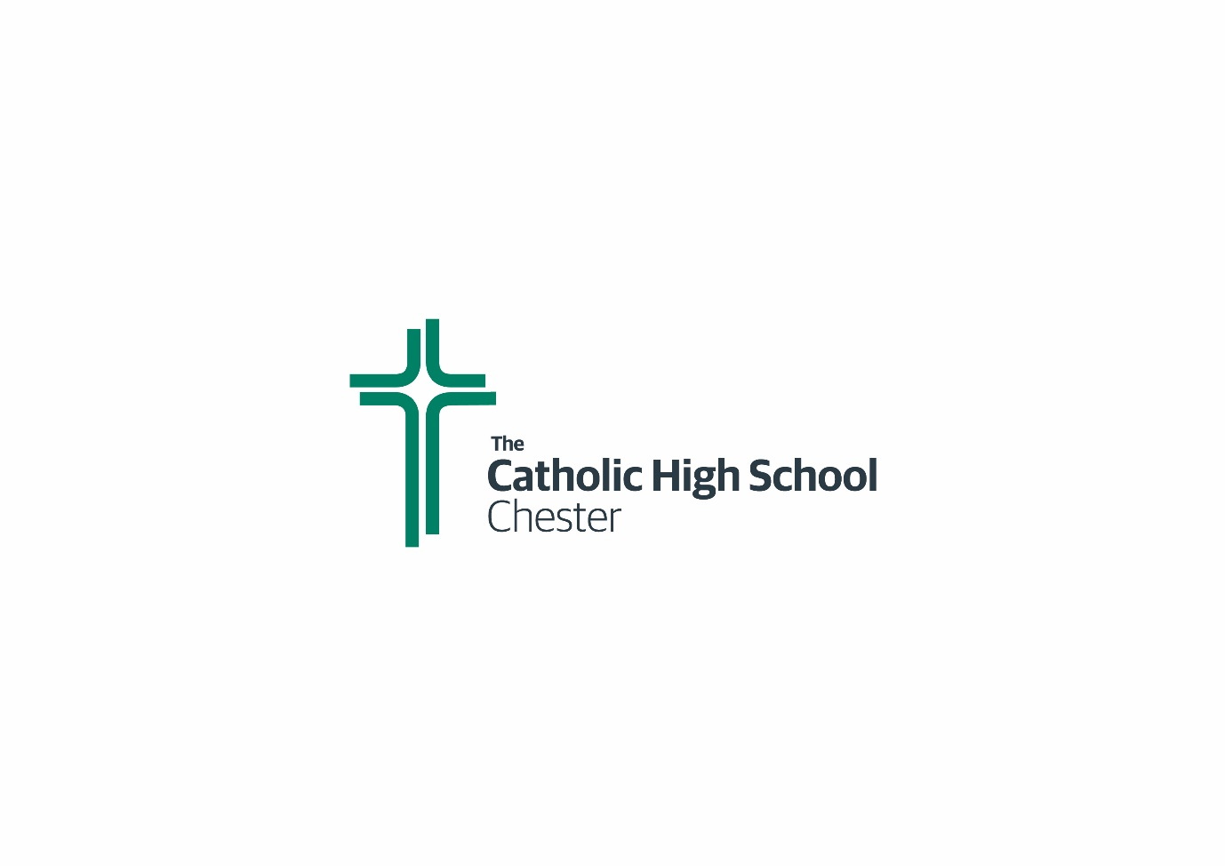

Members of The Trust

Bishop Mark Davies
D. Roberts
Damian Cunningham
Carol Lawrence

